REQUEST

- Log in to the business travel portal using your FBK credential: shttps://missioni.fbk.eu/
- Enter all the information needed to define your business trip. Click the “i” icon for guidance on how to complete the form.
- When completing the form, pay close attention to the job order (commessa) you enter. Once the business travel request is authorized, you will not be able to edit these fields.
- Business trip with a privately-owned vehicle: you must enter your vehicle details in the system once, or use this link: https://my.fbk.eu/formbuilder/form/79
- When completing the form, select: "Preventivo a zero/No expense budget” if you do not expect any costs for FBK, "modalità self/Unassisted management” if the request falls within the limits for self-managed business travel*, "modalità assistita" (Assisted management) if the request falls within the limits that require support-unit management **.

* Self-managed mode must be used for the following types of business travel:
- business connected with a job order with financial reporting with estimated expenses of less than/equal to €200;
- business travel connected to an institutional job order or other than "reporting-required" with estimated expenses of less than/equal to €1000;
- all business travel with no expenses on budget
- all business travel with added vacation/remote work

** Assisted mode can be activated for the following business travel types:
a) business travel connected to job order requiring financial reporting with expenses exceeding €200;
b) business travel connected to an institutional job order or other than "reporting-required" with estimated expenses of less than/equal to €1000;

- Do you plan to use other methods of transportation (e.g. taxi)? Remember to select and provide the reason.
- Do you need an advance? Select the "request" box to receive 50% of the expenses eligible for advance. Business travel feature: more than 24 hours, total budget of more than €400.00
- Please remember to complete the fields related to budgeted expenses. For daily spending limits, always refer to the regulations and related documents.
- For an authorized business travel with an Expense Report in which no expenses have yet been entered, changes to the date and time may be requested only if the reference month has not yet ended.
- If a business trip is not carried out, please request its cancellation in the system through the reference operators.
- If you intend to request reimbursement for expenses incurred in connection with a canceled business trip, please note that the Foundation may cover the costs when the cancellation is due to circumstances beyond the traveler’s control and/or for duly justified reasons.

To protect the interests of the Foundation, travelers are required to strictly comply with the Regulations, paying particular attention to the list of expenses eligible for reimbursement (Article 5 of the Business Travel Regulations), and to contact the Travel Services Office should any issues arise at any stage of the process.

REIMBURSEMENTS

You can only request a reimbursement if you have receipts for tax purposes (ricevuta fiscale), invoices and sales receipts (scontrino), in Italy, or equivalent documentation abroad.
Reimbursement must always be managed directly by the traveler:

via WEBAPP https://missioni.fbk.eu/ during the business travel

or from a PC at https://missioni.fbk.eu/

From WEBAPP:

  - download to your mobile https://missioni.fbk.eu/ and log in with your Google FBK account credentials
  - Click on the Expense Report related to the relevant business travel
  - click "+ Nuova Spesa/New expense"
  - Click on the camera icon, make sure the expense document is well framed and fully visible, and take the photo. The OCR system will import the document data; however, always check that the information is correct when you return to your PC.
  - Click "Salva/Save"

Repeat the procedure for each document for which you are claiming reimbursement.

In the web app, there is no option to delete entries once they have been entered, in order to reduce the risk of accidental deletions. During the verification phase on the PC, however, any entry can be deleted.

A Notes field is available in the webapp for each entry.

You can close the Expense Report only from a PC, after verifying that all information is correct, by clicking the “Request Verification” button.

From PC:

- Enter all amounts in the software together with the date, select the appropriate description from the “Giutificativo/expense item description” drop-down menu (e.g., meal, travel, overnight stay), and enter one item row for each receipt. Do not enter any amount in the VAT field.
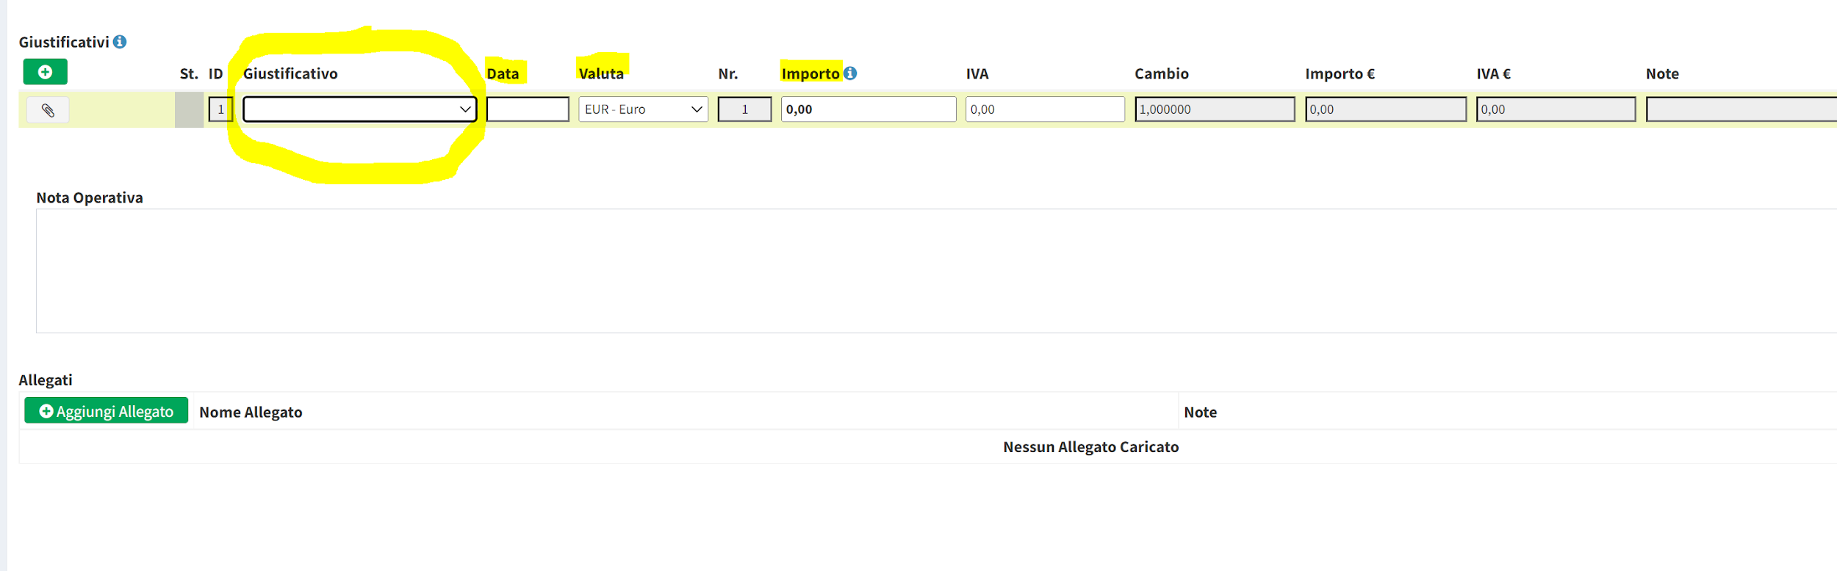
- In the lower-left section under “Attachments”, click “+ Add Attachment” and upload scans of all receipts (a single PDF is acceptable), if they are not already included in the relevant line.
Completion and final verification of the Expense Report from your PC:
- If your travel was connected to a project requiring financial reporting, you must attach the following documents under “Allegati/Attachments” → “+ Aggiungi Allegato/Add Attachment”: flight boarding passes (for boarding passes or QR codes, save the image from your mobile phone and attach it), minutes, agenda, conference program, list of participants, and any work presented. If the documentation is not available, you should attach a note containing a brief description of the activities carried out:
- click "Salva Bozza/Save draft"
- Submit for approval only after verifying that all information is correct

An approved and closed Expense Report cannot be changed.

NOTE:

The total cost of receipts for meals and overnight stays must not exceed the following limits:
Meals: max € 80 per day Italy, € 100 Abroad
Overnight stay: max € 250 per day Italy, € 300 Abroad
If you have foreign currency receipts, select the correct currency from the "Valuta/Currency" drop-down menu.

Receipts in foreign languages other than English, French, Spanish and German must include a description in the "Notes" field (e.g. meal, travel, etc.).

If you indicated the use of your privately-owned vehicle and the route when submitting your request, the reimbursement line for mileage will already be prefilled. Therefore, do not submit fuel receipts. Parking and toll expenses may instead be claimed under “travel reimbursement.” If you use a privately-owned vehicle equipped with a Telepass device, reimbursement for tolls related to the business trip will be granted upon submission of a Telepass expense report issued in the name of the traveler requesting reimbursement. If the Telepass account is registered to a third party, it must be deactivated and a toll payment receipt must be provided; otherwise, the reimbursed amount will be subject to taxation.

ATTENTION: You may close the mileage reimbursement only after the 15th of the month in which the business trip took place. The mileage allowance is calculated based on an estimated fuel consumption of 10 liters per 100 km, multiplied by the price of unleaded gasoline in effect on the first day of the month. Taking into account fixed vehicle costs, the price of unleaded gasoline is increased by 50% for calculation purposes (e.g., 10% × (1.486 × 1.5) = €0.22).
If you indicated the use of a privately owned vehicle and entered mileage when submitting your business travel request, but you do not wish to claim mileage reimbursement, click the “bin” icon at the bottom of the pre-filled mileage reimbursement row to delete it.

If you need to change the entered route, click the car icon. A window will open, allowing you to edit the route as follows: The route eligible for reimbursement is the one from your workplace, or from another location only if it is more cost-effective.

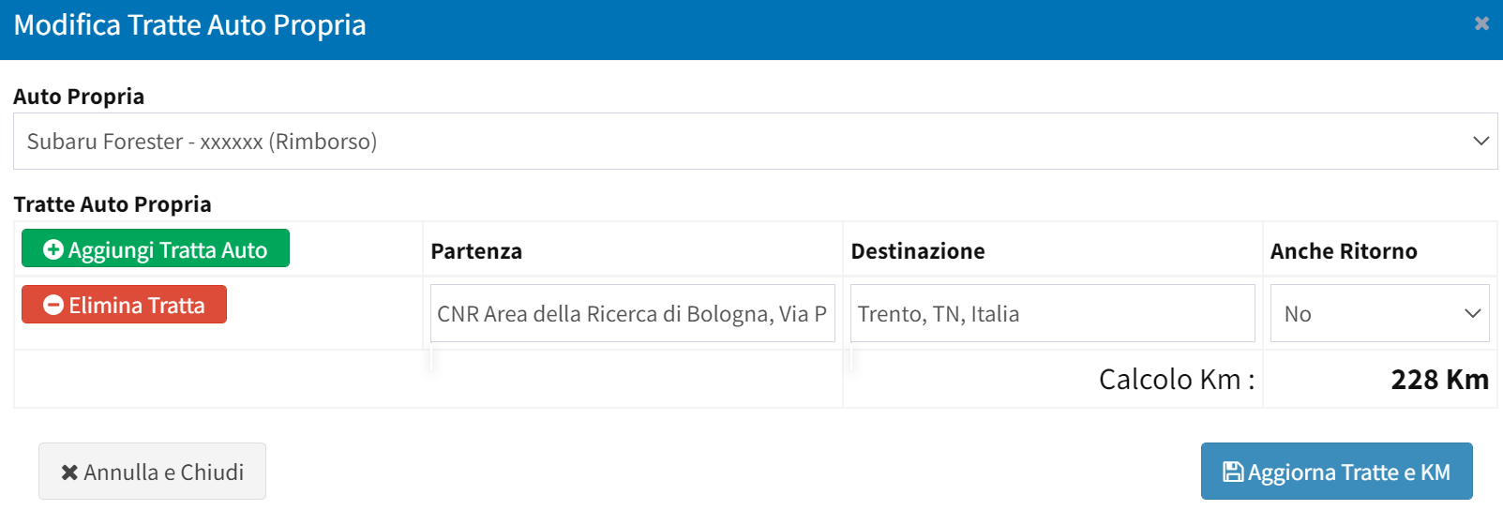

In the case of a single receipt for more than one person, please enter the total amount divided by the number of people (only expenses incurred by the traveler are eligible for reimbursement).

If you have lost a receipt:
- If you do not have the original receipt or a debit statement showing the charge, you must add a “A CEDOLINO/PAYROLL” description row with the cost and date, and note in the “Note” field that the receipt was lost. The amount is not eligible for projects with financial reporting; it will be taxed and paid through payroll

- if you do not have the original receipt but you do have an account statement in your name attesting to the expense, you can attach it by entering a "RICEVUTA MANCANTE/MISSING RECEIPT" description row. The expense will be reimbursed, but it is not eligible for projects that require financial reporting.

Under Italian law, expenses for meals, lodging, and taxis that are paid in cash must be taxed (traceability requirement). In these cases, the “A cedolino/payroll” option must be selected. Some receipts may state “paid in cash” even when a card was actually used; in such cases, proof of the electronic payment (such as a payment receipt or an account statement in the traveler’s name) must be provided and attached.

If you used a taxi but did not select taxi as an authorized mode of transportation, be sure to justify its use by explaining the reason in the “Notes” field.

Note: Expense reports for canceled business travel or for business travel with no reimbursable expenses must still be submitted for authorization and closed, even if the total amount is zero. Zero-budget business travel, however, does not generate an expense report and therefore requires no closing action.

Most of this information can also be found in the "Giustificativi" (expense item) (i) section:
By following these points step by step nothing can go wrong. Remember that travelers are required to act within the limits of the Regulations.
Do not hesitate to contact us for any questions, concerns, support!
We invite you to provide helpful ideas and suggestions for improving these instructions.
Veronica Giordani, ext. 555
Cinzia Zaffoni, ext. 957
Elisa Amore ext. 090
supporto.centri@fbk.eu help-supporto.centri@fbk.eu
Helpful documents in FBK HOW TO

